Raise Exceptions

* Throw

Handling exceptions

* Catch

Predefined List.Empty exception

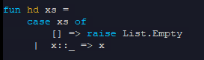

We can also define our own kind of exception

* exception <exception name>



Define exception with values

* exception <exception name> of <type>
* like constructor syntax



* to use this: 

Passing an exception as an argument:

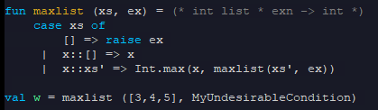

Handling exceptions

* e1 handle ex => e2
* handle <exception name> => <code block of what we’ll do when exception occurs>

No exception occurring:



With exception occurring:



No handle: (program evaluation will stop)

* + uncaught exception





